|  |  |  |  |  |  |  |
| --- | --- | --- | --- | --- | --- | --- |
| VILNIAUS KOLEGIJA  UNIVERSITY OF APPLIED SCIENCES  FACULTY OF ELECTRONICS AND INFORMATICS  Image result for viko logo | | |  | | | VILNIUS COLLEGE  Image result for viko logoFACULTY OF ELECTRONICS AND INFORMATICS |
|  | | |  | | |  |
| **SMART DEVICE SENSORS PROGRAMMING** | | |  | | | **INTRODUCTION TO INFORMATICS** |
| LABORATORY WORK  LABORATORY WORK NR.: 2  6531BX028 PI18E | | |  | | | PRACTICAL ASSIGNMENT  SPOTIFY USER MANUAL  6531BX028 PI18E |
| STUDENT | DŽIUGAS PEČIULEVIČIUS | STUDENT | | DŽIUGAS PEČIULEVIČIUS |
| (SIGNATURE)  1/29/2021 | | |  | | | LECTURER |
| LECTURER | SIMONAS ČESNAUSKAS | (SIGNATURE)  10/17/2018 | | VIRGILIJUS KUKLIERIUS |
| (SIGNATURE)  1/29/2021 | | |  | | | 2018 |

2021

Questions:

1. Describe the structure of BJT, NPN.
2. Which component is described by the following contacts: Drain, Gate, Source
3. What are the advantages of FET type components over BJT?
4. Which, the contact of the component shown below is considered the anode?

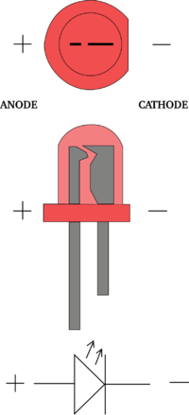

1. What power diodes can be used for?
2. What is a toroid?
3. What is AC?
4. What is DC
5. What is indicated by the symbol below?

Paveikslėlis, kuriame yra žinutė

Automatiškai sugeneruotas aprašymas

1. What is the purpose of the structure scheme?

Answers:

1. BJT & NPN has 3 terminals – Base, Emitter and Collector.
2. FET - Field Effect Transistor.
3. The advantages of FET over BJT are that FETs designed with lower load, and are easier to manufacture.
4. The contact on the left is considered anode.
5. Used for conversion of alternating current into direct voltage.
6. Toroid is an inductor which has a form of a ring. Because it has a form of a ring, toroid is highly efficient. It’s mostly used in medical devices, switching regulators, air conditioners, refrigerators and so on.
7. AC – Alternating Current.
8. DC – Direct Current.
9. Direct Current (DC) is indicated by that symbol.
10. Structure schemes are most of the time the initial stage in the design of a device.